SD 22 School Library to Library Learning Commons
School Committee Planning Process Overview

SD 22 Library Learning Commons: Guiding Principles and Rationale
The Library Learning Commons Planning Process is intended to support schools in their efforts to shift from a Traditional Library to a Library Learning Commons (LLC) model of practice. The school district has provided $370, 000 allocated funds transferred to local capital to support the purchase of furniture and equipment, along with minor renovations, to support the transformation of our traditional libraries to LLC spaces.
The following questions may help guide your conversation as you consider a Library Learning Commons Plan for your school:
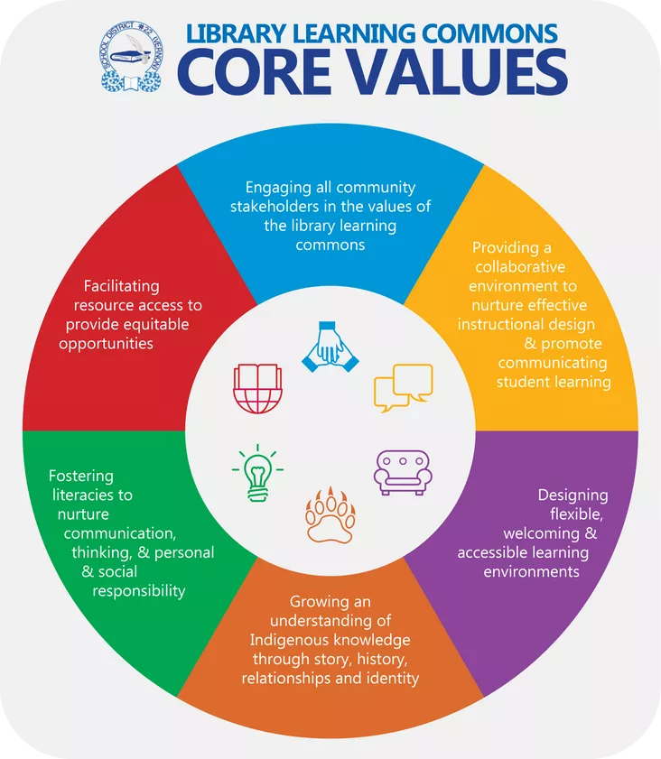 | - What is a Library Learning Commons? (Background information is provided in this document below)  - Where are we now in our school library program, and what would we like our Library Learning Commons to be like?  - How can we work together to envision and design this physical and virtual space?  - How will we promote and extend our vision to reach all members of our school community?  - How is your Library Learning Commons Plan connected with your school’s Technology Plan?  - How will your Library Learning Commons space provide flexible scheduling and invite access to the Library Learning Commons?  - What future steps will your school take to continue your journey towards a Library Learning Commons model, aside from any proposed remodeling outlined above?

Overview of the Library Learning Commons Planning Process
☐ Form a School LLC Committee made up of the teacher-librarian, at least two teachers, and at least one administrator
☐ Review Background LLC Information (links to documents below) with school committee
☐ Complete the School Checklist as a committee to assess your individual school readiness for the transition to a Library Learning Commons: Checklist Page 7 . Please attach a copy to your planning package
☐ Complete the Library Learning Commons Planning Form
☐ Complete a consultation meeting with the Director of Facilities (Archie Stogianos), prior to submission of plan
☐ Submit the Planning Documents and School Checklist to the Director of Instruction for Student Learning (Luke Friesen) by June 11, 2021
- All school plans received will be reviewed by Luke Friesen (Director of Instruction), Archie Stogianos (Director of Facilities), Charity Sakakibara (Director of AbEd), Sterling Olson (Secretary Treasurer).
- Each school that completes this process and submits their school plan will receive funding support from the district. Determination of funding allocations will be based on the number of plans received and the details of each plan. Any school that does not submit a plan in this time frame will still be considered for funding later on, but their plan will not be put in front of those schools who submitted plans in the April 26 - June 11 window. This will help the Facilities Dept. in the planning of these projects as well as give schools who are ready the opportunity to move forward and those that are not more time to create a plan.
Each school that has submitted a plan will be notified about the next steps in the process, including:
- Details about potential timelines for proposed projects.
- Consultation process involved with the facilities department.
Background Information to Assist with Proposal Process
- ‘Transforming Libraries to Library Learning Commons’’ - PowerPoint
- 'SD22 Library Learning Commons Design Booklet’

Acknowledgements
The information contained in this planning package was put together by the Library Learning Commons Committee:
Adrian Johnson, Amanda Smiley, Andrew Taylor, Archie Stogianos, Brad Ogasawara, Corinne McWhinney, Erin Hobkirk, Heather Acob, Jen Carter, Kyle Doerksen, Melissa Yurkowski, Lyle Chapman, Scott Belshaw, Shay Best, Luke Friesen, and Lisa Ball.
The Planning Form is based on the SD36 Library Learning Commons Application Process.
Contact Information
For more information, please contact Luke Friesen at lfriesen@sd22.bc.ca

Library Learning Commons Planning Form

School:Click or tap here to enter text. | Date: Click or tap here to enter text.
School Library Learning Commons Committee Members:
Click or tap here to enter text.

Shared Vision and Connection to Existing Work
How will your committee’s work on this project connect to and extend the ongoing priorities at your school?  Consider the SD 22 Library Learning Commons Values | Click or tap here to enter text.

Project Design Proposal
Please note that flooring, lighting, and painting upgrades are separate from the LLC Plan – Please consult with Archie Stogianos, Director of Facilities, for more details.
What changes to your current library space would be made?  Please provide a drawing or images attached to this package to provide an overview of the ‘before and after’ conditions in the Library Learning Commons | Click or tap here to enter text.
What design elements (furniture, shelving, equipment, colour schemes) would help transition your space to a Library Learning Commons?  Please refer to list of options in the SD22 Library Learning Commons Design Booklet | Click or tap here to enter text.
What proposed changes would be completed by the Facilities Department?  Please provide an overview of proposed work orders  ☐ Consultation Completed with Archie Stogianos, Director of Facilities. | Click or tap here to enter text.

Additional Information
Click or tap here to enter text.

In submitting this Library Learning Commons Plan, our school team is committing to the SD 22 Library Learning Commons Core Values.

